Experiment 7
Navigation and Copy Commands
Aim
To execute cd, cp, and ls commands.
Theory
cd Command
Changes the current directory.
cd Documents
cp Command
Copies files and directories.
cp file1.txt backup.txt

Procedure
- Navigate between directories using cd.
- Copy files using cp.
- Verify copied files using ls.

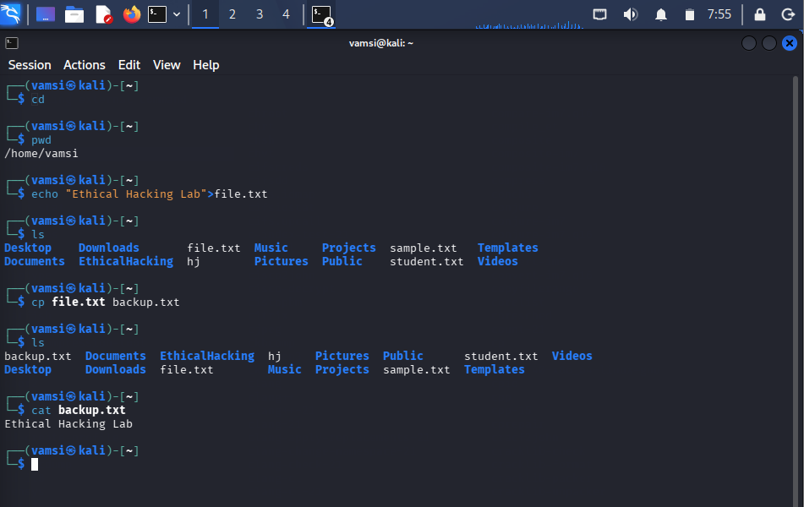

Result
Successfully executed cd, cp, and ls commands.

